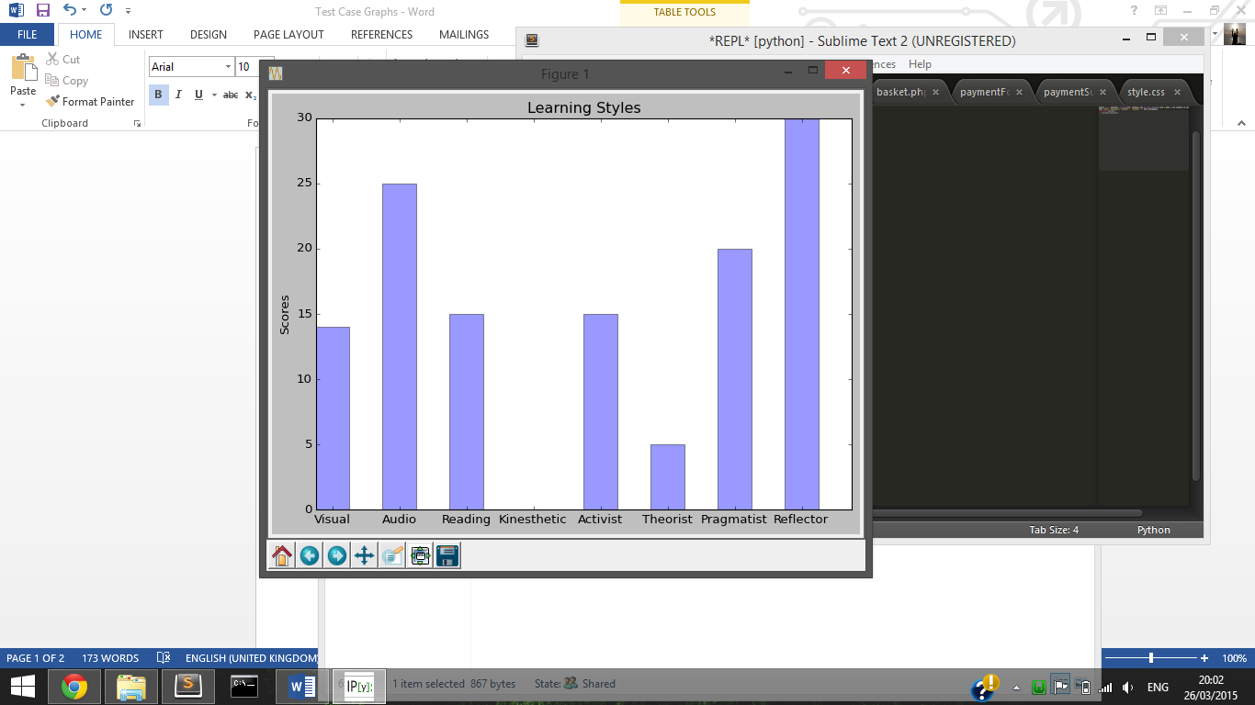

|  |  |  |  |  |  |
| --- | --- | --- | --- | --- | --- |
| **Test Case Id:6** | | **Test Purpose: Does Analysis Graph Display Correct Data** | | | |
| **Environment:** | | | | | |
| **Preconditions: Analysis view, data available** | | | | | |
| **Test Case Steps:** | | | | | |
| Step No | Procedure | | | Response | Pass/Fail |
| 1 | After selecting the data you wish to view e.g. by year, via the analysis page click the make a graph button | | | Bar chart displaying the percentage score for each of 8 categories, values vary depending on analysis selected, in this case totalled for the selected year group. |  |
| 2 | After selecting the data you wish to view e.g. by course, via the analysis page click the make a graph button | | | Bar chart displaying the percentage score for each of 8 categories, values vary depending on analysis selected, in this case totalled for the selected course |  |
| 3 | After selecting the data you wish to view e.g. total, via the analysis page click the make a graph button | | | Bar chart displaying the percentage score for each of 8 categories, values vary depending on analysis selected, in this case totalled for all available results |  |
|  |  | | |  |  |
|  |  | | |  |  |
|  |  | | |  |  |
|  |  | | |  |  |
|  |  | | |  |  |
|  |  | | |  |  |
|  |  | | |  |  |
| **Comments:** | | | | | |
| **Related Tests:Analysis** | | | | | |
| **Author: Matthew Price** | | | **Checker:** | | |